

Computer Network Theory

Assignment # 2

Instructor Name Razia Nisar Noorani

Computer Network Theory
BS Computer Science, Batch 2022F

Case study on Bit Torrent & Netflix

Group Members:
Name | Roll Number
Saad Ali | 2022F-BCS-162
Muzamil | 2022F-BCS-316
Muhammad Faisal | 2022F-BCS-152
Afnan | 2022F-BCS-168

Supervisor

Case study on Bit Torrent

The BitTorrent protocol is a peer-to-peer (P2P) file-sharing protocol designed to efficiently distribute large files over the Internet by breaking them into smaller pieces. Here's how it works and how it differs from traditional file-sharing methods:
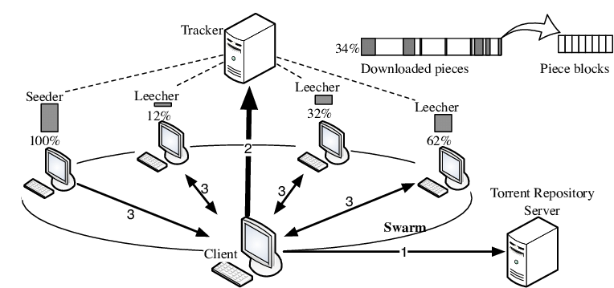

BitTorrent network diagram

How BitTorrent Protocol Works
- File Segmentation:
  - A large file is divided into small pieces, usually of uniform size (e.g., 256 KB or 512 KB).
  - These pieces are hashed, creating unique identifiers to ensure data integrity.
- Torrent File and Tracker:
  - A .torrent file contains metadata about the file being shared, including piece hashes, the file name, and a list of tracker servers.
  - The tracker coordinates peers by maintaining a list of available users sharing the file.
- Swarm Formation:
  - When a user downloads a torrent file and opens it in a BitTorrent client, the client connects to the tracker to find peers (other users who either have or are downloading the file).
  - The network of all peers sharing the same file is called a swarm.
- Downloading and Uploading:
  - Peers download pieces of the file from multiple other peers and upload the pieces they already have.
  - Each peer contributes bandwidth, reducing the load on any single source.
- Seeders and Leechers:
  - A seeder has the complete file and only uploads to other peers.
  - A leecher is still downloading pieces of the file but can upload the pieces they already have to others.
- Piece Exchange Algorithm:
  - BitTorrent uses a "tit-for-tat" algorithm to prioritize peers who upload more. This incentivizes sharing.
  - Once a peer completes downloading all pieces, it becomes a seeder.
- Decentralization:
  - BitTorrent can also function without centralized trackers using Distributed Hash Tables (DHT), allowing peers to find each other without a server.

Differences from Traditional File-Sharing
- Decentralized Distribution:
  - Traditional file-sharing methods (e.g., HTTP, FTP) rely on a central server to host and distribute files.
  - BitTorrent distributes files among peers, reducing server dependency and bandwidth costs.
- Simultaneous Upload/Download:
  - In traditional methods, users only download files from the server.
  - In BitTorrent, users both upload and download, increasing the speed and efficiency of file distribution.
- Swarm Dynamics:
  - File transfer speeds increase with more peers in BitTorrent, as pieces come from multiple sources.
  - Traditional methods can slow down or fail under high demand.
- Resilience to Failures:
  - If the central server goes offline in traditional methods, file sharing stops.
  - BitTorrent works as long as there are active peers in the swarm, even without a tracker.
The Role of Seeders and Leechers in a BitTorrent Network and Their Contribution to File Distribution Efficiency
In a BitTorrent network, "seeders" and "leechers" play crucial roles in the file distribution process.
- Seeders: These are users who have a complete copy of the file and continue to share it with others. They upload pieces of the file to leechers and other peers. The more seeders there are, the more sources there are to download the file from, which helps increase the speed and availability of the file. Seeders ensure that the file remains accessible to others over time.
- Leechers: These are users who are in the process of downloading the file but may not have the complete file yet. They also contribute to the distribution of the file by uploading the parts they have downloaded to other peers. Although leechers primarily focus on downloading, their participation in uploading makes the network more efficient.
Seeders and leechers contribute to the efficiency of file distribution in the following ways:
- Seeders:
  - They provide the complete file to the network, ensuring that the file is always available for download.
  - Since they have the entire file, they can continuously upload parts to other peers, increasing the overall speed and availability of the file.
  - The more seeders there are, the more sources there are to download from, reducing the chances of bottlenecks or slow downloads.
- Leechers:
  - Even though leechers are primarily downloading, they contribute to the network by uploading parts of the file they have already downloaded to others.
  - This helps distribute the file across multiple peers, making the system more efficient and reducing the dependency on seeders alone.
  - Leechers' simultaneous downloading and uploading increase the overall throughput of the network, especially in cases where there are more leechers than seeders.
Together, seeders and leechers create a self-sustaining system. As leechers download and upload, they keep the file distribution process active and ensure that the network does not rely on a single point of failure. This decentralized approach leads to faster downloads, more efficient sharing, and greater resilience in the network.

The Concept of a Torrent File in BitTorrent and Its Role in Facilitating File Sharing
A "torrent file" is a small file that contains metadata about the files you want to share, but not the actual content of the files themselves. It plays a crucial role in the BitTorrent protocol and facilitates the sharing of large files across the network in the following ways:
- Metadata Storage:
  - The torrent file includes information about the files you are downloading or uploading, such as file names, sizes, and folder structures.
  - It also contains information about the tracker, which helps coordinate the file-sharing process and find peers in the network.
- Piece Information:
  - Torrents break large files into smaller chunks or "pieces." The torrent file includes details about how the file is divided into these smaller pieces, allowing peers to download parts of the file from multiple sources simultaneously.
  - This division into smaller pieces makes it easier to download files in parallel from different peers, speeding up the process.
- Tracker Information:
  - The torrent file contains URLs of the tracker(s) that help find peers. The tracker is responsible for coordinating the connection between peers, ensuring that they can share pieces of the file with each other.
  - While the tracker manages the initial peer discovery, BitTorrent also supports a decentralized model where peers can find each other without needing a central tracker (using Distributed Hash Tables or DHT).
- Efficient File Sharing:
  - Once the torrent file is opened by a BitTorrent client, it uses the metadata to locate other peers that have parts of the file. Peers can then exchange pieces of the file based on availability.
  - This decentralized approach reduces the load on a single server and ensures that large files can be shared efficiently across a network of users.
By providing the necessary metadata and instructions for how files are split and shared, the torrent file enables efficient and fast distribution of large files without relying on a central server. This makes BitTorrent particularly useful for sharing large amounts of data like movies, software, or large datasets.
BitTorrent vs Other Methods
Advantages of BitTorrent
- Faster Download Speeds: With BitTorrent you download pieces of a file from multiple users at the same time. This means faster download speeds especially for large files.
- Distributed Network: BitTorrent doesn't rely on a single server. This makes it more resilient and less prone to crashes.
- Seeders and Leechers: Once you finish downloading a file you become a "Seeder" and help others download it. This creates a self-sustaining network.
Disadvantages of BitTorrent
- Legal Concerns: BitTorrent is often used to share copyrighted material which can lead to legal trouble.
- Security Risks: Downloading from untrusted sources can expose you to malware and viruses.
- Bandwidth Consumption: Uploading parts of the file can consume a lot of bandwidth.
Comparison with Other Methods
Direct Downloads
- Advantages: Simple and straightforward.
- Disadvantages: Relies on a single server which can be slow and unreliable for large files.
FTP
- Advantages: Good for transferring files between computers.
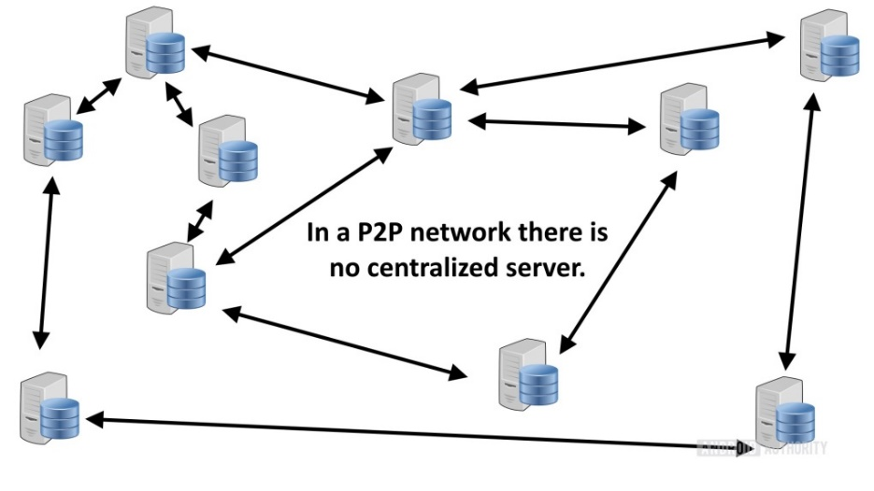
- Disadvantages: Can be slow and limited by server capacity.

Ensuring Data Integrity and Reliability in BitTorrent During File Sharing
BitTorrent ensures data integrity and reliability through a combination of techniques, even when files are split into multiple parts.
Hashing: Each file or file part is assigned a unique hash value, a digital fingerprint generated by a cryptographic algorithm. This hash acts as a checksum, verifying the integrity of the data.
Merkle Tree: For large files, a Merkle tree is used. This is a hierarchical structure where each node represents a hash of its child nodes. By comparing hashes at different levels, clients can verify the integrity of specific parts without downloading the entire file.
Peer Verification: Clients exchange hashes with other peers. If a downloaded piece's hash doesn't match the expected value, it's discarded and requested again from a different peer.
Redundancy: Multiple peers have copies of each file part, increasing the likelihood of obtaining correct data.
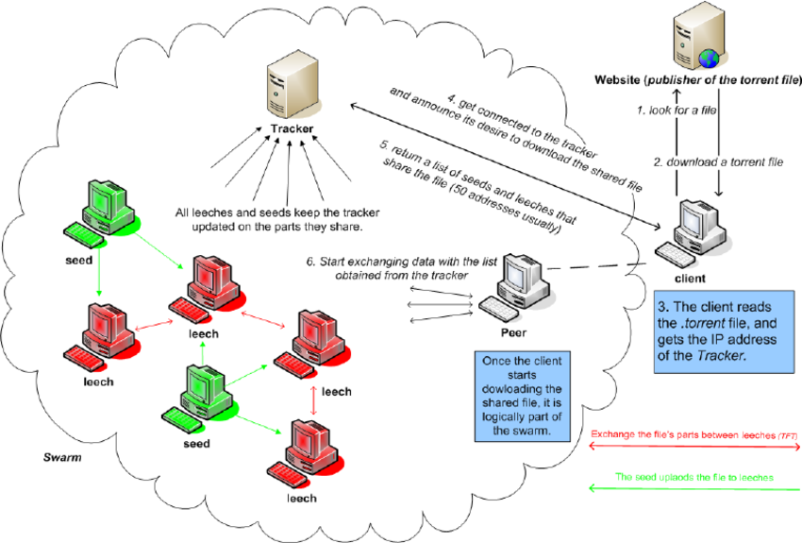
Incremental Verification: Clients can verify parts of a file as they download, allowing for early detection of errors.

In the diagram:
- File is split into Parts.
- Each Part has a unique Hash.
- Peers exchange Hashes and Parts.
- Clients verify Hashes to ensure data integrity.
- Merkle Tree enables efficient verification of large files.
By employing these mechanisms, BitTorrent significantly enhances the reliability and accuracy of file sharing, even in scenarios where files are divided into multiple parts.

Addressing Copyright Infringement in BitTorrent and Protecting Intellectual Property
BitTorrent, as a protocol, is neutral regarding the content shared over it, but various measures and mechanisms are in place to address copyright infringement and protect intellectual property:

1. Measures Taken by BitTorrent to Address Copyright Infringement
- Tracker Moderation:
  - Some trackers enforce policies to ban torrents associated with copyrighted material.
  - Trackers monitor shared content and can remove infringing files from their listings.
- DMCA Notices:
  - Torrent websites and trackers operating under U.S. jurisdiction comply with Digital Millennium Copyright Act (DMCA) takedown requests.
  - Infringing torrents are removed upon receiving such notices.
- Blocking by ISPs:
  - Internet Service Providers (ISPs) may monitor BitTorrent traffic and block or throttle connections associated with illegal file-sharing.
- Legal Action:
  - Organizations like the Motion Picture Association (MPA) and Recording Industry Association of America (RIAA) track illegal sharing and initiate lawsuits against infringers.

2. How Content Creators Protect Intellectual Property in BitTorrent
- Private Trackers:
  - Creators can use private trackers that require authentication or membership to share files securely with specific audiences.
- Digital Rights Management (DRM):
  - Files distributed via BitTorrent may be encrypted or protected with DRM to restrict unauthorized use.
- Watermarking:
  - Digital watermarking embeds traceable markers in files, enabling creators to track unauthorized sharing.
- Legal Torrents:
  - Content creators can distribute their files via official, licensed torrent websites to control and monetize their content.
- Using BitTorrent Tokens:
  - The BitTorrent Token (BTT) incentivizes users for sharing legitimate content, creating a controlled ecosystem for distributing legal materials.

3. Content Distribution Platforms Using BitTorrent
- Platforms like BitTorrent Now and other authorized portals allow creators to share their work legally, ensuring they retain control over distribution while benefiting from BitTorrent’s efficiency.
By combining enforcement mechanisms, secure distribution practices, and technological safeguards, BitTorrent can balance its efficiency with intellectual property protection.

Common Challenges and Limitations of Using BitTorrent and Solutions
BitTorrent is an efficient file-sharing protocol, but it faces several challenges and limitations. Developers and the community have introduced solutions to address these issues:

1. Bandwidth Throttling by ISPs
- Challenge:
  - Internet Service Providers (ISPs) may throttle or block BitTorrent traffic to reduce network congestion caused by high data usage.
- Solutions:
  - Encryption: BitTorrent clients like uTorrent and qBittorrent offer encryption to hide traffic patterns from ISPs.
  - VPN Usage: Virtual Private Networks (VPNs) help mask BitTorrent activity, preventing throttling or blocking.

2. Copyright Infringement
- Challenge:
  - BitTorrent's decentralized nature makes it easy for users to share copyrighted materials without authorization.
- Solutions:
  - Torrent websites implement content moderation and comply with takedown notices.
  - Platforms encourage legal distribution through private trackers and authorized portals.

3. Peer Availability
- Challenge:
  - Downloads can slow down or fail if there are insufficient seeders or peers.
- Solutions:
  - Incentive Models: Private trackers reward users for seeding by granting higher download speeds or access to exclusive torrents.
  - DHT (Distributed Hash Table): Allows peers to connect directly without relying on central trackers.

4. Malware and Fake Torrents
- Challenge:
  - Malicious users may upload fake torrents containing malware or misleading content.
- Solutions:
  - BitTorrent clients include comment and rating systems for user feedback.
  - Trusted trackers and websites like The Pirate Bay verify and highlight legitimate torrents.

5. Uneven Contribution
- Challenge:
  - Some users, known as leechers, download without contributing back to the swarm, reducing efficiency.
- Solutions:
  - BitTorrent employs a tit-for-tat algorithm, prioritizing peers who share data.
  - Private trackers enforce seeding ratios to ensure balanced sharing.

6. Legal and Ethical Concerns
- Challenge:
  - BitTorrent’s association with piracy has created a stigma, leading to restrictions and bans in certain regions.
- Solutions:
  - Promoting legitimate uses of BitTorrent, such as distributing large datasets or open-source software.
  - Educating users about ethical and legal file sharing.

7. Resource Intensity
- Challenge:
  - BitTorrent clients can be resource-intensive, consuming significant bandwidth and system memory.
- Solutions:
  - Modern clients optimize resource usage with features like bandwidth scheduling and priority-based downloading.
  - Developers create lightweight clients tailored for low-resource environments.
By addressing these challenges through technological innovations and community practices, BitTorrent remains a powerful tool for decentralized and efficient file sharing.
The Evolution of BitTorrent: A Deep Dive
BitTorrent, a decentralized peer-to-peer (P2P) file-sharing protocol, has revolutionized the way we consume digital content. By dividing files into smaller chunks and distributing them across a network of peers, BitTorrent significantly improves download speeds and efficiency. This case study explores the evolution of the BitTorrent protocol, highlighting key improvements and changes that have enhanced its performance and security.
The Birth of BitTorrent
Bram Cohen, a computer programmer, introduced the BitTorrent protocol in 2001. Its innovative approach to file sharing quickly gained popularity due to its ability to handle large file transfers efficiently.
Key Components of BitTorrent
- Torrent File: A metadata file containing information about the file being shared, including its size, hash, and a list of trackers.
- Tracker: A centralized server that coordinates the communication between peers.
- Peers: Individual computers participating in the P2P network.
- Swarm: A group of peers actively sharing a specific file.
Evolution of BitTorrent Protocol
The BitTorrent protocol has undergone significant evolution since its inception. Here are some key improvements:
1. Distributed Hash Table (DHT):
- Centralization Reduction: DHT replaces the centralized tracker with a decentralized network of nodes.
- Improved Resilience: DHT makes the network more resilient to tracker failures.
- Enhanced Peer Discovery: Peers can discover each other directly without relying on a central authority.
2. Magnet Links:
- Direct Peer-to-Peer Sharing: Magnet links allow users to share files directly without the need for a torrent file.
- Simplified Sharing: Users can share files by simply sending a magnet link.
3. Protocol Encryption:
- Enhanced Security: Encryption helps protect user privacy and data integrity.
- Secure Communication: Encrypted communication prevents eavesdropping and tampering.
4. BitTorrent v2:
- Improved Performance: BitTorrent v2 introduces several performance optimizations, such as faster handshake and connection establishment.
- Enhanced Security: Stronger encryption and authentication mechanisms are incorporated.
- Flexible Block Sizes:
Variable block sizes allow for more efficient data transfer.
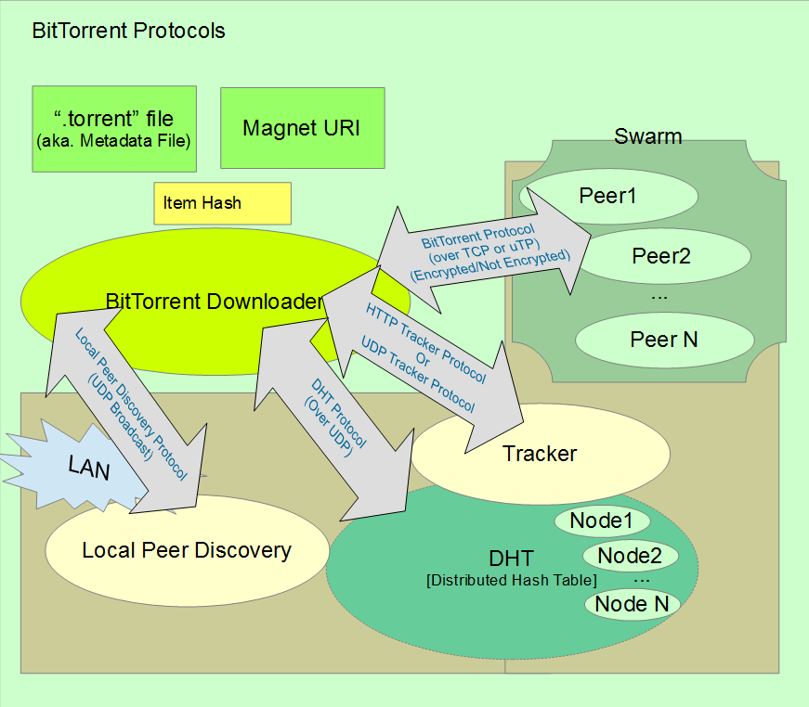
Diagram: Evolution of BitTorrent Protocol

Diagram showing the evolution of BitTorrent, including the original protocol, DHT, magnet links, encryption, and BitTorrent v2
Challenges and Future Directions
Despite its advancements, BitTorrent still faces challenges, including:
- Copyright Infringement: The protocol has been associated with illegal file sharing.
- Network Congestion: Large-scale file sharing can lead to network congestion.
- Security Vulnerabilities: While encryption has improved security, vulnerabilities still exist.
To address these challenges, future developments may include:
- Incentivization Mechanisms: Implementing reward systems to encourage fair sharing and discourage free-riding.
- Enhanced Privacy: Exploring more advanced privacy-preserving techniques.
- Integration with Blockchain Technology: Leveraging blockchain for secure and transparent file sharing.
The BitTorrent protocol has come a long way since its inception. Its innovative approach to decentralized file sharing has made it a popular choice for distributing large files efficiently. By addressing challenges and embracing emerging technologies, BitTorrent can continue to evolve and shape the future of digital content distribution.
Decentralized Tracking in BitTorrent: A Key to Scalability and Resilience
BitTorrent, a popular peer-to-peer file-sharing protocol, relies on decentralized tracking to ensure its scalability and resilience. Unlike traditional centralized tracking systems, where a single server coordinates the network, BitTorrent employs a distributed hash table (DHT) to distribute tracking responsibilities across multiple nodes.
How Decentralized Tracking Works:
- DHT Node Network: The DHT consists of a network of nodes that store and route information about files and peers.
- Peer Discovery: When a peer joins the network, it connects to a random node in the DHT.
- Routing: The DHT uses a distributed algorithm to route queries for specific files to the appropriate nodes.
- Peer Exchange: Nodes in the DHT share information about other peers, enabling direct peer-to-peer connections.
Benefits of Decentralized Tracking:
- Scalability: The DHT can handle a large number of peers without overloading a single server.
- Resilience: The network is more resilient to failures, as there is no single point of failure.
- Censorship Resistance: Decentralization makes it difficult for authorities to censor the network.
- Privacy: By removing the need for a central authority, decentralized tracking can enhance user privacy.
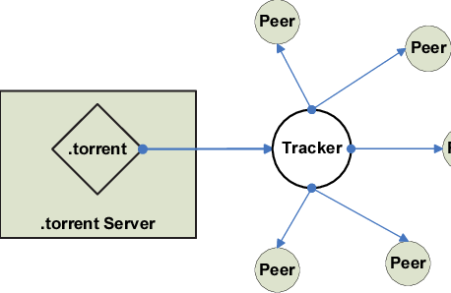
Diagram: Decentralized Tracking in BitTorrent



The Diagram illustrating the decentralized tracking mechanism in BitTorrent, showing the DHT, nodes, and peertopeer connections
Real-world Example: The Impact of Decentralized Tracking
During peak usage times, popular torrent sites can experience a surge in traffic. With decentralized tracking, the load is distributed across multiple nodes, preventing any single server from becoming overwhelmed. This ensures smooth operation and prevents bottlenecks, even under heavy load.
In Conclusion
Decentralized tracking is a fundamental aspect of BitTorrent's success. By distributing the tracking responsibilities across multiple nodes, the protocol achieves remarkable scalability, resilience, and censorship resistance. This innovative approach has made BitTorrent a powerful tool for efficient file sharing and content distribution.
Beyond File Sharing: The Versatile Applications of BitTorrent Technology
While BitTorrent is primarily known for its role in peer-to-peer file sharing, its underlying technology has found applications in various industries, offering innovative solutions to diverse challenges.
1. Content Delivery Networks (CDNs):
- Efficient Content Distribution: By leveraging BitTorrent's peer-to-peer capabilities, CDNs can distribute large files efficiently, reducing server load and improving delivery speeds.
- Reduced Bandwidth Costs: By utilizing the bandwidth of peers, CDNs can lower costs associated with content delivery.

2. Software Distribution:
- Faster Downloads: BitTorrent can accelerate software downloads, especially for large applications.
- Reduced Server Load: By offloading the download traffic to peers, servers can handle more users and maintain optimal performance.
3. Data Backup and Synchronization:
- Efficient Data Transfer: BitTorrent can be used to synchronize large files and backups between multiple devices.
- Distributed Backup: Data can be distributed across multiple peers, improving data durability and redundancy.
4. Live Streaming:
- Reduced Server Load: BitTorrent can be used to distribute live streams, reducing the load on the primary servers.
- Improved Streaming Quality: By leveraging peer-to-peer connections, viewers can experience better streaming quality, especially in congested networks.
5. Blockchain and Cryptocurrency:
- Distributed Ledger Technology: BitTorrent's decentralized nature aligns with the principles of blockchain.
- Efficient Data Transfer: BitTorrent can be used to distribute large blockchain blocks and transactions.
6. Scientific Research:
- Data Sharing: Researchers can use BitTorrent to share large datasets efficiently.
- Collaborative Research: The peer-to-peer nature of BitTorrent can facilitate collaboration among researchers.
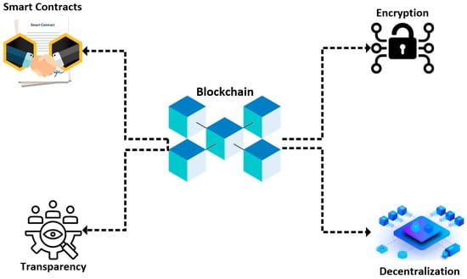
Diagram: Diverse Applications of BitTorrent Technology

The diagram illustrating the various applications of BitTorrent technology, including content delivery, software distribution, data backup, live streaming, blockchain, and scientific research
Real-world Example: BitTorrent in Scientific Research
Scientists often work with massive datasets that are difficult to share and distribute. BitTorrent provides an efficient solution by allowing researchers to share large files directly with each other, reducing the strain on servers and accelerating data dissemination.

Case study on Netflix

Introduction
Netflix, once a humble DVD-by-mail service, has revolutionized the way we consume entertainment. Its innovative approach to content delivery and consumption has transformed the traditional television and entertainment industry. This case study delves into the key ways in which streaming services like Netflix have reshaped the industry.
Key Transformations
- Shift from Linear to On-Demand Viewing:
  - Traditional TV: Viewers were bound to specific broadcast schedules.
  - Netflix: Offers binge-watching, allowing viewers to watch shows at their own pace.
- Original Content Dominance:
  - Traditional TV: Relied heavily on syndicated content.
  - Netflix: Invests heavily in original series and movies, attracting a global audience.
- Data-Driven Personalization:
  - Traditional TV: Broadcasts to a mass audience.
  - Netflix: Utilizes algorithms to recommend content based on individual preferences.
- Global Reach and Localization:
  - Traditional TV: Primarily focused on domestic audiences.
  - Netflix: Offers localized content and subtitles, catering to a diverse global audience.
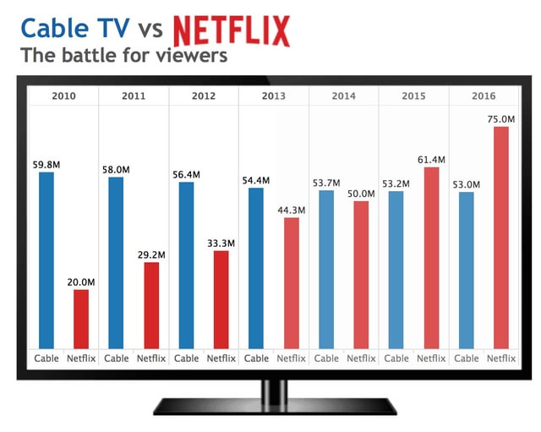
Diagram: Traditional TV vs. Netflix

The diagram comparing traditional TV and Netflix, highlighting key differences in content delivery, viewing experience, and user control
Impact on the Traditional Television Industry
- Decline of Traditional TV Viewership: As streaming services gain popularity, traditional TV viewership has declined, especially among younger demographics.
- Increased Competition: Traditional TV networks face increased competition from streaming services, forcing them to adapt and innovate.
- Shift in Advertising Revenue: Advertisers are shifting their budgets from traditional TV to digital platforms, affecting the revenue model of TV networks.
- Rise of Original Content: Traditional TV networks are investing more in original content to compete with streaming services.
Key Factors Contributing to Netflix's Success and Differentiation
Netflix's dominance in the streaming market can be attributed to several key factors:
1. Original Content Strategy:
- High-Quality Productions: Netflix invests heavily in producing original series and movies, often with A-list talent.
- Diverse Content Library: Catering to a wide range of tastes, from dramas and comedies to documentaries and anime.
- Global Appeal: Creating content that resonates with audiences worldwide.
2. Data-Driven Personalization:
- Advanced Algorithms: Netflix uses sophisticated algorithms to analyze viewing habits and recommend tailored content.
- Personalized Recommendations: Improving user experience and increasing engagement.
- Dynamic Content Delivery: Optimizing the streaming experience based on individual preferences.
3. Seamless User Experience:
- Intuitive Interface: A user-friendly interface that is easy to navigate.
- High-Quality Streaming: Consistent video quality and minimal buffering.
- Multiple Device Compatibility: Accessing content across various devices.
4. Strong Brand Reputation:
- Innovative Approach: Pioneering the streaming industry and setting new standards.
- Customer-Centric Focus: Prioritizing user satisfaction and addressing feedback.
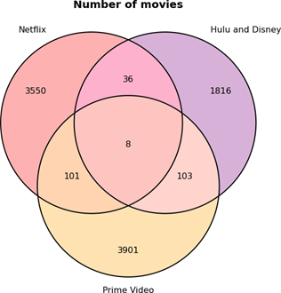
- Effective Marketing Campaigns: Promoting original content and building brand awareness.
Venn Diagram:
Venn diagram comparing Netflix to other streaming platforms, highlighting overlapping areas like ondemand streaming and original content, as well as unique differentiators like datadriven personalization and strong brand reputation.
Netflix's Differentiation:
- Unique Selling Proposition (USP): Original content, data-driven personalization, and strong brand reputation.
- Competitive Advantage: By focusing on these key areas, Netflix has established a significant advantage over its competitors.
By combining these factors, Netflix has successfully differentiated itself from other streaming platforms and solidified its position as a leading entertainment provider.

Netflix's Data-Driven Personalization: A Deep Dive
Netflix's success hinges on its ability to deliver highly personalized content recommendations. The platform leverages sophisticated algorithms and data analytics to curate a unique viewing experience for each user.
How Netflix Personalizes Content:
- Data Collection:
  - Viewing History: Tracks what users watch, pause, and rewind.
  - Ratings and Reviews: Records user ratings and reviews for shows and movies.
  - Search and Browse Behavior: Analyzes user search queries and browsing habits.
  - Device Information: Collects data on the devices used to access Netflix.
- Algorithm Development:
  - Machine Learning Models: Develops complex algorithms to analyze user data and predict preferences.
  - Collaborative Filtering: Identifies similar users and recommends content they enjoyed.
  - Content-Based Filtering: Recommends content similar to what a user has watched in the past.
- Personalized Recommendations:
  - Home Page Customization: Tailors the home page to feature content likely to interest the user.
  - Row and Title Recommendations: Suggests specific rows and titles based on user preferences.
  - Personalized Rankings: Ranks content within rows to prioritize the most relevant options.
Flowchart:
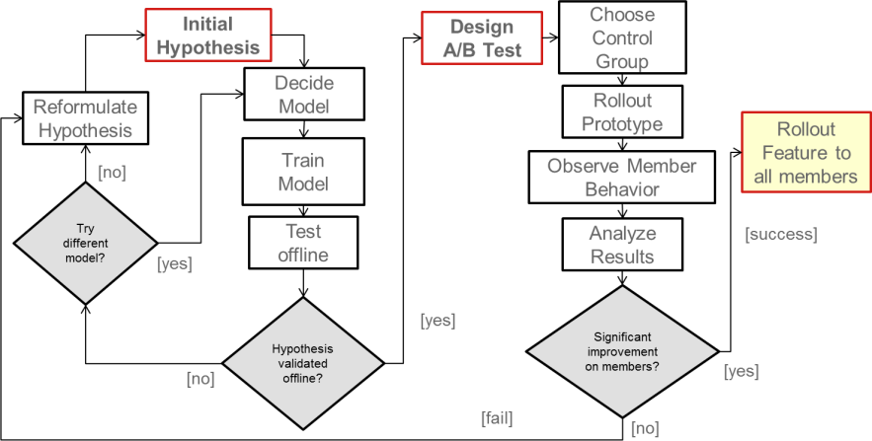

The flowchart illustrating the data collection, processing, algorithm development, and personalized recommendation steps
Impact on User Engagement:
- Increased Viewing Time: Personalized recommendations keep users engaged for longer periods.
- Reduced Churn: Satisfied users are less likely to cancel their subscriptions.
- Enhanced User Experience: Tailored recommendations make it easier for users to discover new content they enjoy.
- Higher Revenue: Increased engagement and reduced churn contribute to higher revenue for Netflix.

The Impact of Netflix Originals on Global Television and Film Production
Netflix's investment in original content has significantly reshaped the global television and film industry.
Key Impacts:
- Disruption of Traditional Production Models:
  - Increased Risk-Taking: Netflix's subscription model allows for bolder storytelling and experimentation with diverse genres and formats.
  - Global Production Hubs: The platform has led to the emergence of new production hubs beyond Hollywood, fostering local talent and industries.
- Elevating the Role of the Creator:
  - Creative Freedom: Netflix often grants creators significant creative autonomy, resulting in innovative and groundbreaking shows.
  - Direct-to-Consumer Model: By bypassing traditional distribution channels, creators can reach a global audience directly.
- Redefining the Television Viewing Experience:
  - Binge-Watching Culture: Netflix popularized the binge-watching phenomenon, transforming how audiences consume television.
  - Global Phenomenon: The platform has produced numerous international hits, transcending cultural boundaries.
Regional Content Restrictions and Licensing Challenges
Netflix operates in a global market, where content licensing and distribution rights vary significantly from country to country. This presents unique challenges in delivering a consistent and seamless viewing experience to its diverse user base.
Handling Regional Content Restrictions
To navigate these complexities, Netflix employs several strategies:
- Geo-Blocking:
  - Netflix uses IP addresses to determine a user's location and restricts access to content that is not licensed for that region.
  - This ensures compliance with licensing agreements and prevents unauthorized viewing.
- Content Curation:
  - Netflix curates its content library for each region, offering a mix of global titles and locally produced shows and movies.
  - This approach caters to the specific preferences of different audiences.
- Content Licensing Negotiations:
  - Netflix negotiates complex licensing deals with content producers and distributors worldwide.
  - These agreements often involve exclusive rights, territorial restrictions, and windowing periods.
Challenges in Licensing and Distribution
Netflix faces several challenges in licensing and distribution:
- High Licensing Costs:
  - Acquiring popular content can be expensive, especially for exclusive rights.
  - This impacts Netflix's profitability and ability to invest in original content.
- Complex Licensing Agreements:
  - Navigating the intricate web of licensing rights and restrictions can be time-consuming and costly.
  - Different countries have varying copyright laws and regulations, further complicating the process.
- Content Availability and Quality:
  - Ensuring consistent content availability and quality across different regions can be challenging.
  - Factors such as censorship, language barriers, and technical limitations can impact the user experience.

The Impact of Binge-Watching on Viewer Habits and Content Consumption
Netflix has significantly contributed to the rise of binge-watching, a phenomenon where viewers consume multiple episodes of a TV series in one sitting. This trend has reshaped the way audiences engage with content and has had far-reaching implications for the entertainment industry.
Key Impacts of Binge-Watching:
- Changed Viewer Expectations:
  - Immediate Gratification: Binge-watching caters to the desire for instant gratification, leading to higher viewer expectations for quick plot development and cliffhangers.
  - Immersive Viewing Experiences: Consuming multiple episodes consecutively creates a more immersive and intense viewing experience.
- Influenced Content Creation:
  - Longer Seasons: Binge-watching has enabled creators to produce longer seasons with more complex storylines.
  - Cliffhanger Endings: To encourage binge-watching, shows often end seasons with cliffhangers, leaving viewers eager for the next season.
- Altered Television Landscape:
  - Decline of Traditional TV: Binge-watching has contributed to the decline of traditional TV viewing, as audiences increasingly turn to streaming services.
  - Rise of Original Content: Streaming services like Netflix have invested heavily in original content to attract binge-watchers.
Interconnections between Binge-Watching, Viewer Expectations, Content Creation, and the Television Landscape
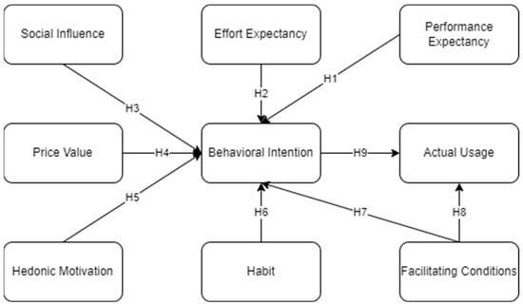

The diagram showing the interconnections between BingeWatching, Viewer Expectations, Content Creation, and the Television Landscape
Netflix's Role in Popularizing Binge-Watching:
- Releasing Entire Seasons at Once: This strategy encourages viewers to watch multiple episodes consecutively.
- Creating Compelling Storytelling: Netflix's original series often feature complex storylines and intricate character arcs, making them ideal for binge-watching.
- Personalized Recommendations: Netflix's algorithm suggests shows and movies based on viewing history, further fueling binge-watching.

The Role of Technology in Delivering High-Quality Streaming Experiences on Netflix
Netflix relies heavily on technology to provide seamless and high-quality streaming experiences to its millions of subscribers. The platform has continuously adapted to advancements in internet infrastructure and device capabilities to ensure optimal performance.
Key Technological Factors:
- Content Delivery Networks (CDNs):
  - Netflix utilizes a vast network of servers distributed globally to deliver content efficiently.
  - CDNs reduce latency and improve streaming quality by caching content closer to users.
- Video Encoding and Compression:
  - Advanced video codecs are employed to compress video files without compromising quality.
  - This enables efficient streaming and reduces bandwidth requirements.
- Adaptive Bitrate Streaming (ABR):
  - Netflix adjusts the video bitrate dynamically based on network conditions and device capabilities.
  - This ensures smooth playback, even in low-bandwidth environments.
- Edge Computing:
  - By processing data closer to the source, edge computing reduces latency and improves response times.
  - This is especially beneficial for interactive features and personalized recommendations.
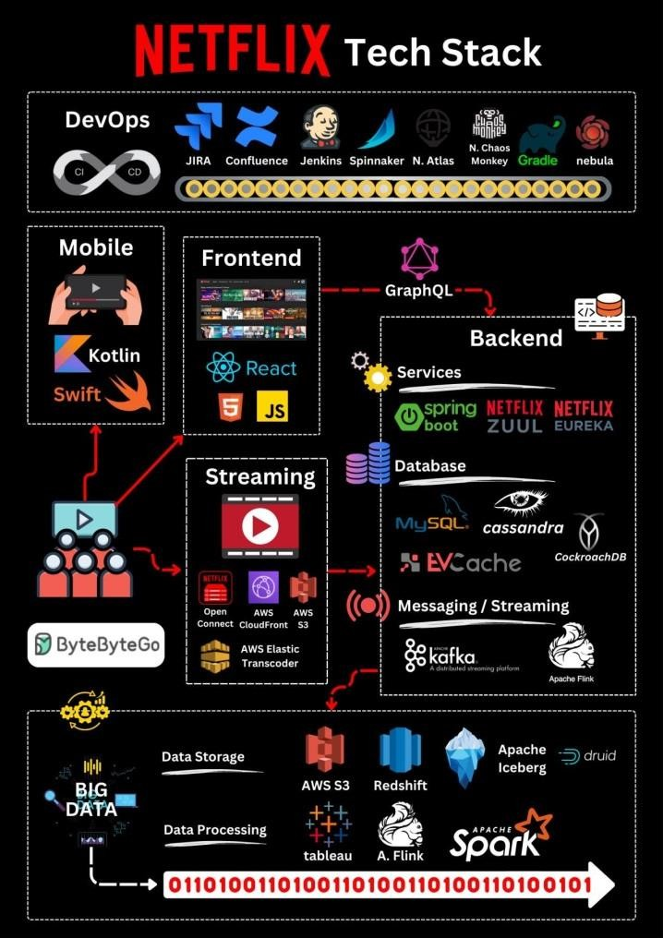
- Artificial Intelligence and Machine Learning:
  - AI and ML algorithms are used for tasks such as:
    - Content Recommendation: Suggesting tailored content to individual users.
    - Quality Control: Monitoring and improving video quality.
    - Fraud Detection: Identifying and preventing account fraud.
Netflix's Technological Stack
Layers:
- Top Layer: User Interface
- Middle Layer: Application Servers
- Bottom Layer: Content Delivery Network (CDN)
Data Flow:
- User Request: The user requests content from the UI.
- Application Server Processing: Application servers process the request and interact with the CDN.
- Content Delivery: The CDN delivers the content to the user's device.

Layered diagram showcasing Netflix's technological stack

Netflix's Approach to Data Privacy and Security
Netflix has prioritized data privacy and security as it collects and analyzes vast amounts of user data to personalize content recommendations. The company has implemented several measures to safeguard user information:
1. Transparent Data Practices:
- Clear Privacy Policy: Netflix maintains a transparent privacy policy that outlines how user data is collected, used, and shared.
- Informed Consent: Users are informed about data collection and have the option to opt out or adjust their privacy settings.
2. Robust Security Measures:
- Encryption: Netflix employs strong encryption techniques to protect user data both at rest and in transit.
- Regular Security Audits: The company conducts regular security audits and vulnerability assessments to identify and address potential threats.
- Incident Response Plans: Netflix has well-defined incident response plans to quickly mitigate the impact of security breaches.
3. Data Minimization:
- Limited Data Collection: Netflix collects only the necessary data to provide its services and improve user experience.
- Data Retention Policies: The company has specific data retention policies to limit the storage of sensitive information.
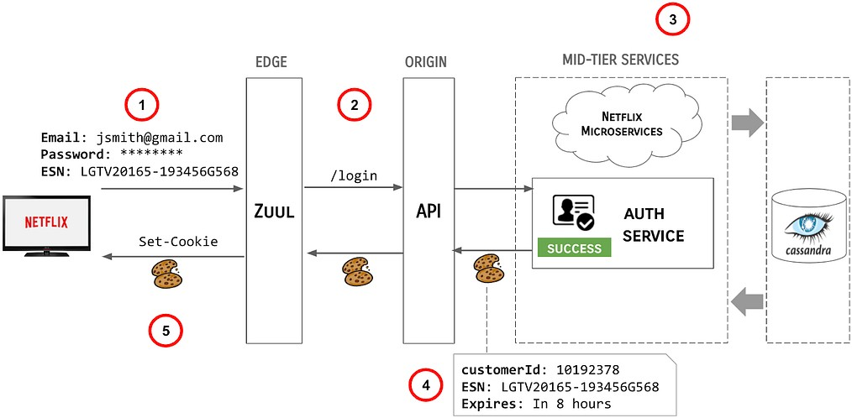
Netflix's Data Privacy and Security Framework

The layered diagram showcasing Netflix's data privacy and security framework
Layers:
- Layer 1: User Data: Personal information, viewing history, preferences
- Layer 2: Data Collection and Processing: Secure data collection methods, data anonymization and aggregation, regular data audits
- Layer 3: Security Measures: Encryption, firewalls, intrusion detection systems, regular security assessments
- Layer 4: Privacy Policies and Compliance: Transparent privacy policy, compliance with data protection regulations (e.g., GDPR, CCPA), user consent and control over data
- Layer 5: Incident Response: Incident detection and response plans, regular security training for employees, third-party security audits
By implementing these measures, Netflix aims to protect user privacy, maintain trust, and ensure the security of its platform.

Netflix's Innovation Amidst Increasing Competition
The streaming industry has become increasingly competitive, with numerous players vying for market share. This intensified competition presents both challenges and opportunities for Netflix.
Potential Effects of Increased Competition:
- Market Share Erosion: As new players enter the market, they may attract subscribers away from Netflix.
- Rising Content Costs: The need to produce high-quality original content to stay competitive can drive up costs.
- Increased Price Pressure: Competition can lead to price wars, impacting Netflix's revenue.
Netflix's Innovation Strategies:
To maintain its competitive edge, Netflix has implemented several innovative strategies:
- Content Differentiation:
  - Niche Content: Investing in niche genres and international content to cater to diverse audiences.
  - Original Content: Continuously producing high-quality original series and films.
  - Exclusive Licensing Deals: Securing exclusive rights to popular content.
- Personalized User Experience:
  - Advanced Algorithms: Utilizing sophisticated algorithms to tailor recommendations to individual preferences.
  - Interactive Content: Experimenting with interactive storytelling formats.
- Expanding Distribution Channels:
  - Mobile-First Strategy: Optimizing content for mobile devices.
  - Gaming Integration: Incorporating gaming into the Netflix platform.
  - Global Expansion: Expanding into new markets and localizing content.

Overcoming the Hurdles: Content Discovery and Retention at Netflix
Netflix has mastered the art of keeping viewers engaged by tackling the challenges of content discovery and retention. Here's a breakdown of their strategies and how they use data to win over users in the long run.

Content Discovery: Finding the Perfect Match
- User Interaction: User watches a show, rates content, or browses categories.
- Data Collection: Viewing data, ratings, search history, and device usage are collected.
- Recommendation Engine: Algorithm analyzes user data and identifies patterns.
- Content Suggestions: Personalized recommendations appear on the user's homepage and within categories.
- Content Curation: Curated rows and genre sections further enhance discoverability.
- User Engagement: User watches recommended content, further feeding data into the system.
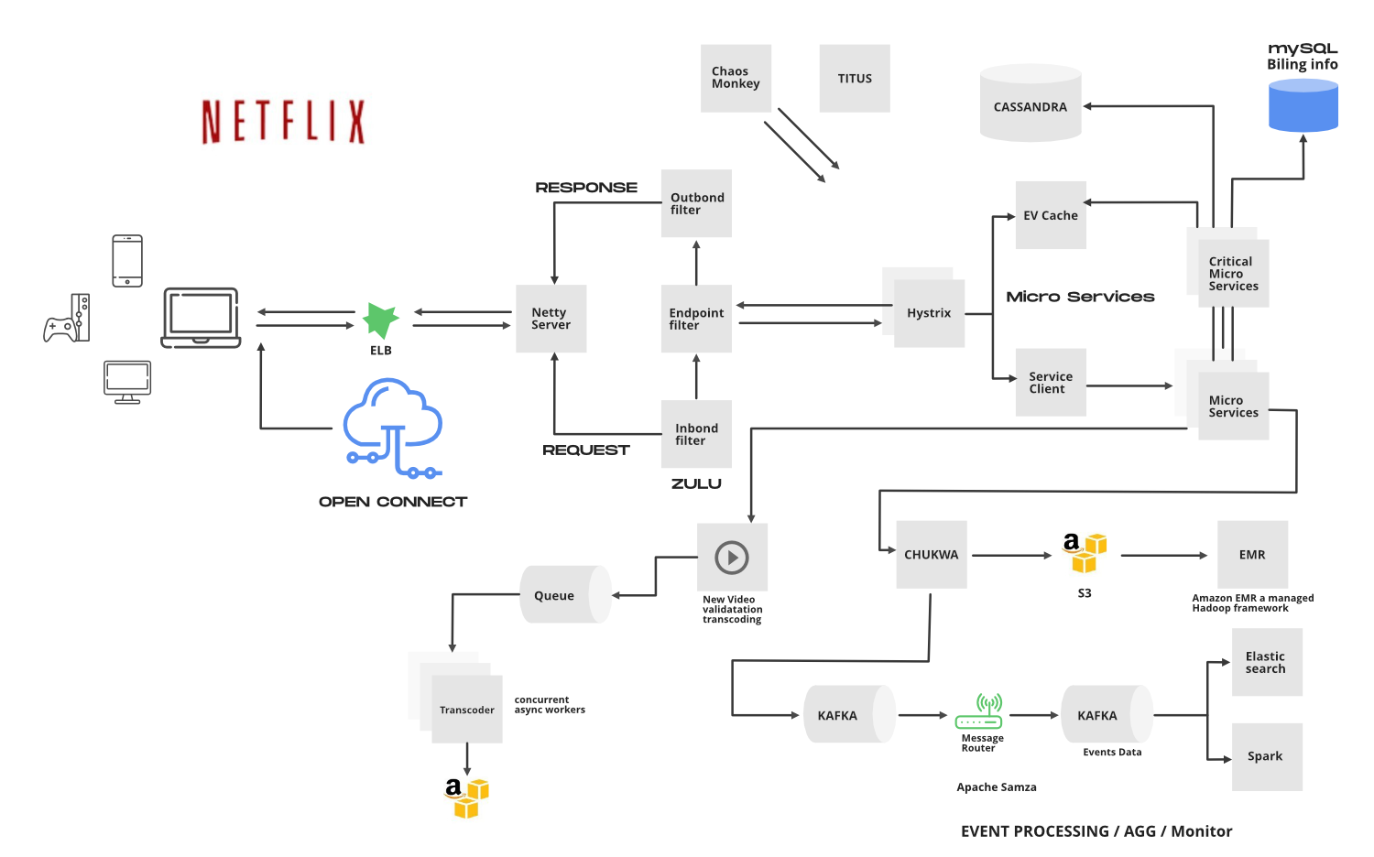

Flowchart illustrating the content discovery process at Netflix

Retention Strategies: Keeping Viewers Hooked
- Original Content: Netflix invests heavily in producing high-quality original series and movies. This exclusive content creates a sense of urgency and keeps users coming back for more.
- Regular Content Updates: New seasons, movies, and documentaries are added frequently, providing a constant stream of fresh content and preventing user churn.
- Interactive Experiences: Netflix has experimented with interactive content formats like "Black Mirror: Bandersnatch" to increase user engagement and create a more immersive viewing experience.
- Downloadable Content: The ability to download content for offline viewing makes Netflix more convenient and caters to users with limited internet access.
Conclusion
Netflix has revolutionized the entertainment industry by shifting from traditional linear television to on-demand streaming. The platform's focus on original content, data-driven personalization, and global reach has attracted millions of subscribers worldwide. However, challenges like data privacy, content discovery, and retention continue to shape the industry. By addressing these challenges through robust security measures, innovative recommendation algorithms, and diverse content offerings, Netflix aims to maintain its position as a dominant force in the streaming landscape.

